**ShopBridge Application RunBook**

1. Once the **ShopBridge** application is loaded into the browser, default product details will be displayed through below screen:

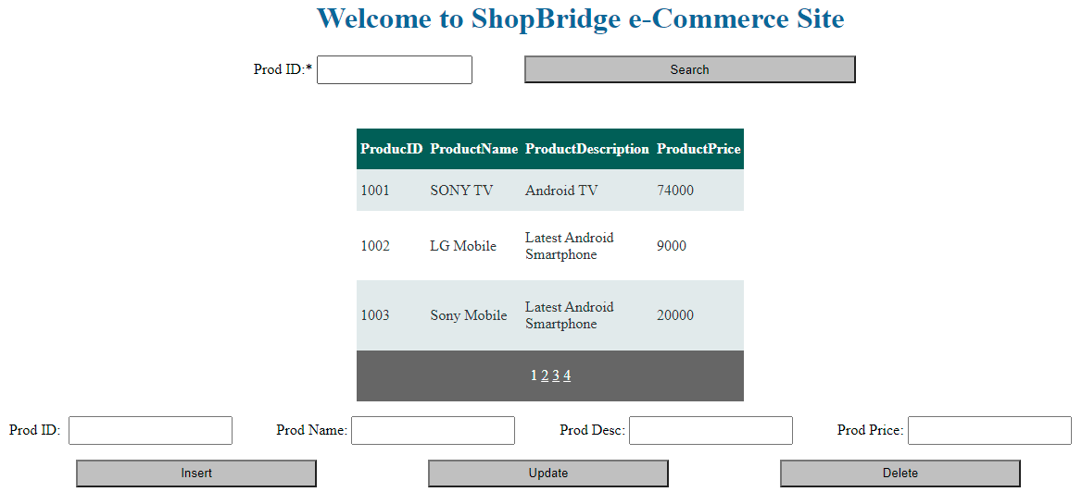

1. User can enter Prod ID in the below textbox and click on **Search** button to retrieve particular product detail:

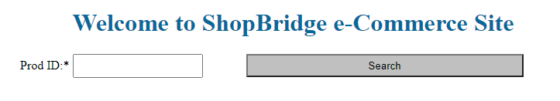

1. If user doesn’t enter any Prod ID and click on **Search** button, a validation error will be displayed on the screen for Prod Id as highlighted below:

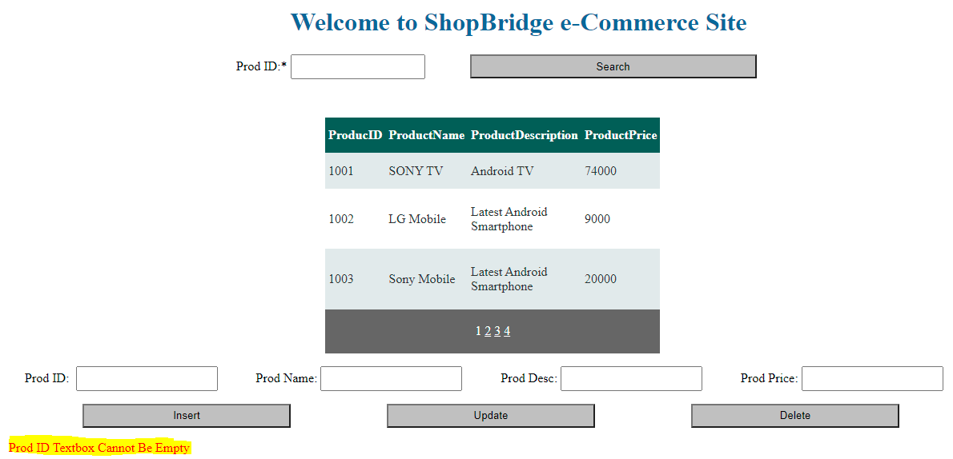

1. When user need to enter a new product, need to fill all the below textboxes before clicking on **Insert** button



1. If any of the above textboxes are empty for inserting a new product, a validation error will be displayed as below:

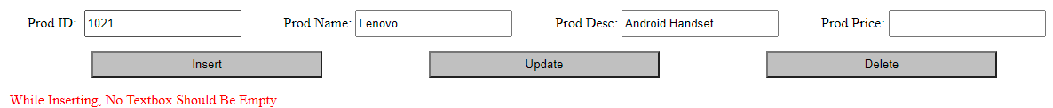

1. Similarly, if any product detail to be updated, all the textboxes should be filled up with new/existing data for the update operation.
2. Once a new product is inserted, below dialog box will be displayed as confirmation:

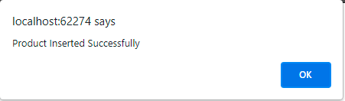

1. User can also navigate to other pages/products through pagination as below:

